## **Market Segmentation:**

## **Identifying the Ideal Customer for Electric Vehicles in India**

Sri Deekshith Labba

16th June, 2024

Github link: <https://github.com/Deekshithlabba/Market_Segmentation_EV_market>

**Executive Summary**

The Indian Electric Vehicle (EV) market is in its early stages, presenting a significant opportunity for new entrants. However, to achieve success, it's crucial to understand the target customer. This report details the process of customer segmentation using behavioral data of existing car owners to identify the ideal demographic for EV adoption.

**1. Market Segmentation Approach**

Since data on EV ownership is limited, this study utilizes customer behavior data from a dataset of conventional car owners in India. This data allows for basic behavioral and demographic analysis to understand potential EV customer segments.

Behavioral And Psychographic Analysis

Customer segmentation based on patterns of behavior shown by consumers when they engage with a business or brand or make a purchase is known as behavioral segmentation. It enables companies to categorize their clientele based on factors like product, service, or brand knowledge, attitudes, usage, or reactions. A consumer's lifestyle, interests, and opinions must be understood in order to apply the psychographic segmentation strategy. Because a consumer's purchasing activity reflects their lifestyle, hobbies, and beliefs, we have merged the two sorts of study.

The dataset we used is a survey of owners of specific brands of fuel-powered automobiles. It includes some basic characteristics like age, salary, marital status, loan status, number of dependents, education, and occupation, as well as the make and price of the car.

**2. Observations from Data Analysis**

* **Age:** A correlation exists between age and car price. Younger buyers tend to purchase less expensive vehicles due to factors like lower income and fewer dependents.

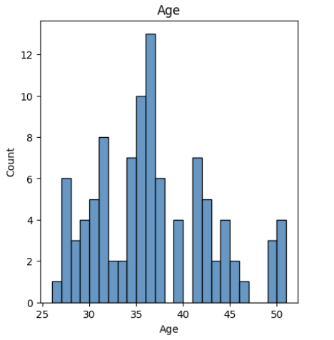

* **Number of Dependents:** Customers with more dependents are more likely to buy SUVs or vehicles with more seating capacity.

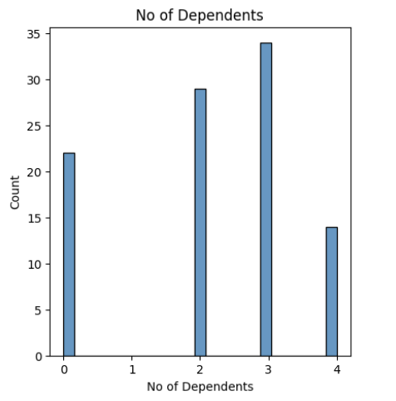

* **Salary:** A positive correlation is observed between salary and car price, indicating a rational purchasing pattern.

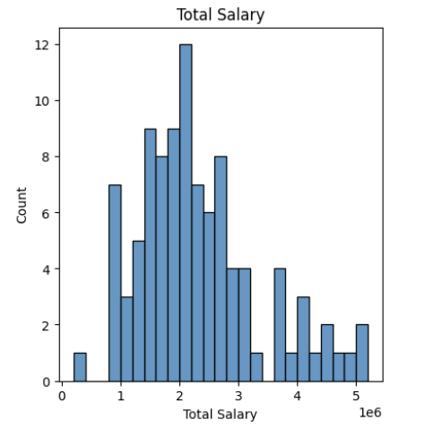

* **Car Price:** This data point reflects a customer's past spending habits on vehicles, providing insight into their affordability range for future purchases.

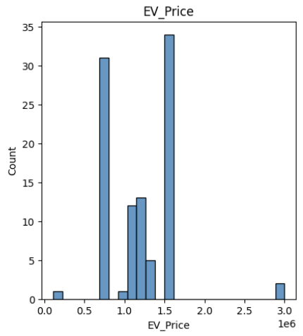

**3. Segmentation Methodology**

* **K-Means Clustering:** This unsupervised learning technique is employed to group customers into distinct segments based on their characteristics. The optimal number of clusters (K) is determined using the Elbow Method, which identifies the point where the explained variance plateaus.

Unsupervised learning techniques like K-means clustering are used to unlabelled data, or data that lacks clear classifications or groups. This algorithm's objective is to identify groups within the data, with the variable K denoting the number of groups. Using the given features, the algorithm iteratively assigns each data point to one of K groups. The similarity of features is used to cluster data points. The K-means clustering algorithm's findings are:

1. The K cluster centroids, which are useful for labeling fresh data.

2. Training data labels (each data point belongs to a separate cluster)

In a K-means analysis, the term "means" denotes the process of averaging the data, or locating the center.

The K-Means Clustering follows these steps:

1. Indicate how many segments you want there to be.

2. From data set X, choose k observations (consumers) at random to serve as the first set of cluster centroids, C = {c1,..., ck}.

3. To divide the data into k market segments S1,..., Sk, assign each observation xi to the nearest cluster centroid. This indicates that a representative from the beginning segment is allocated to each consumer in the data collection. In order to do this, the distance between each customer and each segment representation is calculated, and the consumer is then placed in the market segment with the representative who is the most like them.

4. Recalculate the cluster centroids (segment representatives) by minimizing the distance between each consumer and the corresponding cluster centroid while maintaining a fixed cluster membership.

Step 3 should be repeated until convergence is achieved or a predetermined maximum number of iterations is reached. At this point, the partitioning algorithm's stepwise procedure comes to an end, and the segmentation solution is deemed to be the best one.

**4. Libraries Used**

* **NumPy:** Scientific computing library.
* **Pandas:** Data analysis library for working with dataframes.
* **Matplotlib & Seaborn:** Data visualization libraries for creating informative charts and graphs.
* **Plotly:** Another data visualization library.
* **KModes:** K-means clustering library specifically designed for categorical data.
* **MPL ToolKit:** Library for creating 3D graphs.

**5. Implementation Steps**

* **Data Acquisition:** Utilized a dataset on Indian car-purchasing behavior.
* **Data Cleaning:** Ensured no missing values exist in the dataset.
* **K-Means Clustering:** Employed the Elbow Method to determine the optimal number of clusters (K).
* **Segment Profiling:** Analyzed the characteristics of each identified segment.

**6. Target Customer Identification**

Based on the analysis:

* Younger demographics (25-40 years old) are typically more receptive to new technologies like EVs due to environmental awareness.
* However, affordability remains a concern for this age group, as they tend to purchase less expensive vehicles.

Therefore, the ideal target segment likely falls within the 25-40 age range with:

* **Financial stability** to afford EVs.
* **Openness to new technology**.

**Additional Considerations**

* **Location:** Customers in metropolitan areas with established charging infrastructure and access to information about EVs are more likely to be early adopters.
* **Marital Status:** Married individuals with dependents are statistically more likely to own a car.

**7. Marketing Mix Strategies**

Having identified the target customer, the next step is to develop a marketing mix that caters to their preferences:

* **Product:** Since EVs are a relatively new concept, a focus on customer education and support services (charging stations, maintenance) is crucial. The initial product offerings should target the mid-range segment (₹8-20 lakh) for faster market penetration. A modern design with advanced technology can attract younger demographics.
* **Price:** Affordability is a significant barrier to EV adoption. The product should be competitively priced within the ₹10-20 lakh range, aligning with the typical car purchase budget in India.
* **Place:** Establishing a strong presence in major cities is essential due to better infrastructure and a higher concentration of educated individuals who are more likely to embrace EVs.

**8. Conclusion**

By implementing customer segmentation and profiling techniques, this study has identified the ideal target customer for the Indian EV market: young professionals (25-40 years old) residing in metropolitan areas, with financial stability and a willingness to adopt new technologies. Coupled with a strategic marketing mix that addresses affordability concerns and leverages advancements in technology and design, EV companies can effectively target this segment and accelerate market penetration in India.

**References:**

● https://jmkresearch.com/registered-ev-sales-in-india-in-2020-dropped

-by-26-on-yoy-basis/

● <https://jmkresearch.com/registered-ev-sales-drop-20-y-o-y-in-fy2021/>

Datasets:

● https://www.kaggle.com/karivedha/indian-consumers-cars-purchasing

-behaviour

● https://www.kaggle.com/datasets?search=+EV+market+data